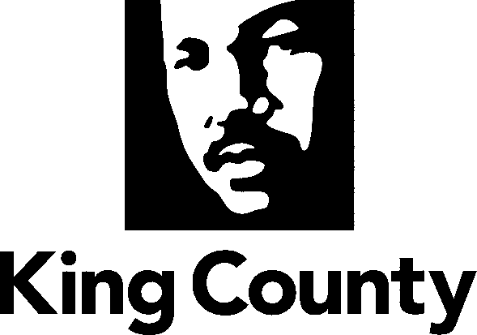
Student
Internship development
Worksheet

Name:
School:
Education Track or Program of Study:
Learning Objectives of Internship Associated with Program of Study:
_1. _______________________________________________________________________
_2. _______________________________________________________________________
_3._______________________________________________________________________

